2026 NI Road Safety Awards  Nomination Form | 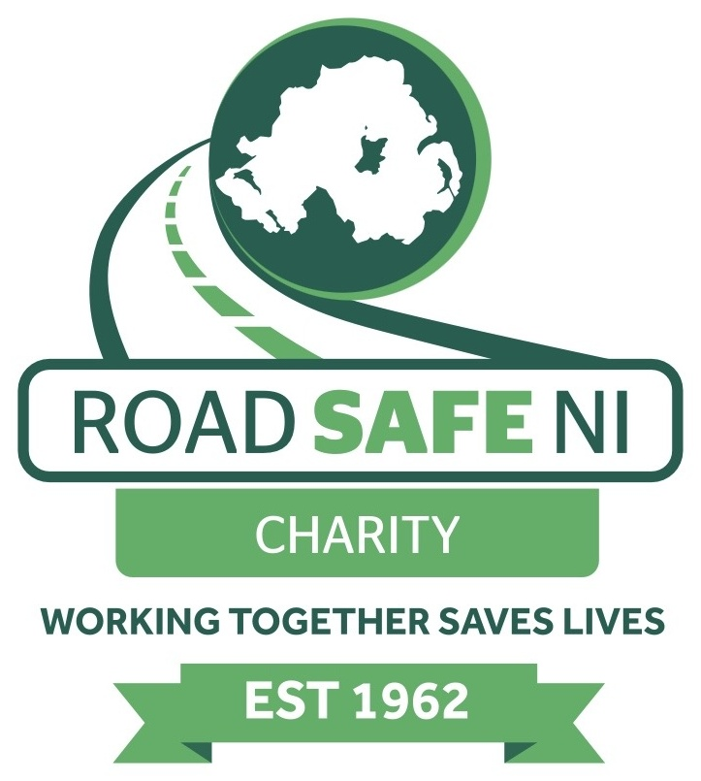
Use this form to nominate an individual, school, organisation or group whose work has made a positive contribution to road safety in Northern Ireland. Self-nominations are welcome.
Closing date for entries: Friday 30 October 2026

1 Award category
Please tick one category. If you are unsure, select the category that best reflects the nominee's main contribution.
☐ Primary School | ☐ Post-Primary School
☐ Open Category | ☐ Business Sector
☐ Voluntary Award | ☐ Approved Driving Instructor
☐ School Crossing Patrol Person | ☐ Emergency Services
☐ Young Driver | ☐ Public Sector
☐ LGV/PCV | ☐ Lifetime Achievement

2 Person making the nomination
Full name
________________________________________________________________________________________
Organisation and role if applicable
________________________________________________________________________________________
Email address  ______________________________________ | Telephone number  ______________________________________
Is this a self-nomination? ☐ Yes ☐ No

3 Nominee details
Name of person, school, organisation or group being nominated
________________________________________________________________________________________
Nominee's organisation or role if applicable
________________________________________________________________________________________
Nominee's email address or telephone number if known
________________________________________________________________________________________

Supporting information
Please answer each question in no more than 100 words. You may type into the spaces or complete the form clearly in black ink.
Question 1 Maximum 100 words
What has the nominee done to improve road safety?
Describe the activity, initiative, service or sustained contribution. Include how long the nominee has been involved where relevant.
Question 2 Maximum 100 words
What difference has the nominee's work made?
Explain who benefited and describe any results, achievements, evidence or examples that demonstrate the impact.

Supporting information continued
Question 3 Maximum 100 words
Why should this nominee receive a 2026 NI Road Safety Award?
Tell the judging panel what makes the nominee's contribution exceptional and why it deserves recognition.

4 Declaration
I confirm that the information provided in this nomination is accurate to the best of my knowledge. I understand that Road Safe NI Charity may contact me for further information about this nomination.
Signature: _______________________________________ Date: ____________________

5 Sending your nomination
Email: roadsafetyawards@roadsafeni.org
Post: Road Safe NI Charity, 48 Copperthorpe, Londonderry, BT47 3LT
Please ensure all sections are completed before submitting your nomination.

